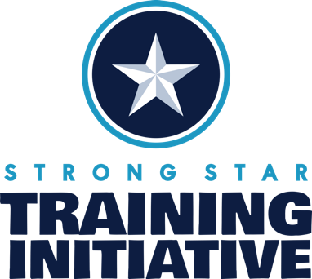

Written Exposure Therapy Workshop
Training Description

Target Audience: Mental health providers

Instructional Level: Introductory

Course Description: This live, virtual workshop for mental health professionals provides training in Written Exposure Therapy (WET), an evidence-based treatment for PTSD. This workshop will present the theory and rationale for WET, an overview of WET’s empirical support, and step-by-step instructions for delivering the WET protocol. Throughout the workshop, strategies for conceptualizing and dealing with co-morbidity, managing avoidance, and keeping patients optimally engaged will be provided.

Posttraumatic stress disorder (PTSD) is a prevalent and debilitating disorder. Although effective treatments for PTSD have been identified, there are barriers to both delivering and receiving these treatments. From the patient perspective, treatments are time consuming (e.g., number of sessions and between session assignments), which accounts for high dropout rates (e.g., 50%; Kelhe-Forbes et al., 2016). From a provider perspective, PTSD treatments involve substantial training to be able to effectively deliver, and the time required to prepare for treatment sessions serves as an additional barrier (Finley et al., 2015). WET represents an alternative evidence-based PTSD treatment approach that is efficient and associated with low treatment dropout rates (e.g., Sloan et al., 2012; 2013). Moreover, WET has been found to be non-inferior to Cognitive Processing Therapy and Prolonged Exposure.

Learning Objectives:

At the end of this course, participants will be able to:

- Explain the diagnostic criteria for PTSD according to the DSM-5.
- Discuss research providing empirical support for WET for PTSD.
- Describe evidence for WET across diverse populations and settings.
- Describe the theory and putative mechanisms underlying WET.
- List the critical elements of the WET protocol.
- Demonstrate providing writing instructions per the WET protocol to facilitate trauma processing.
- Prepare feedback on example patient narratives.
- Demonstrate engaging in post-writing discussion to process the experience of exposure.
- Describe ways that WET can be adapted to accommodate individual patient factors.
- Prepare WET patients to utilize skills to address future goals after the completion of WET.

Primary Goal: After completion of this training, mental health providers will be able to effectively implement WET.

Date and Time: Wednesday, June 5 and Thursday, June 6 from 9:00 am to 3:30 pm CST
Duration: 2-day workshop
Where: Zoom
Training Cost: $350 for eligible providers

WET Manual

Purchase of the WET manual is a necessary supplement to the training. The WET manual is available online via Amazon.com: Written Exposure Therapy for PTSD: A Brief Treatment Approach for Mental Health Professionals
Authors: Denise M. Sloan and Brian P. Marx
ISBN-13: 978-1433830129
ISBN-10: 978-1433830129

Meet the Presenters

Stefanie LoSavio, PhD, ABPP
Director of Research and Innovation

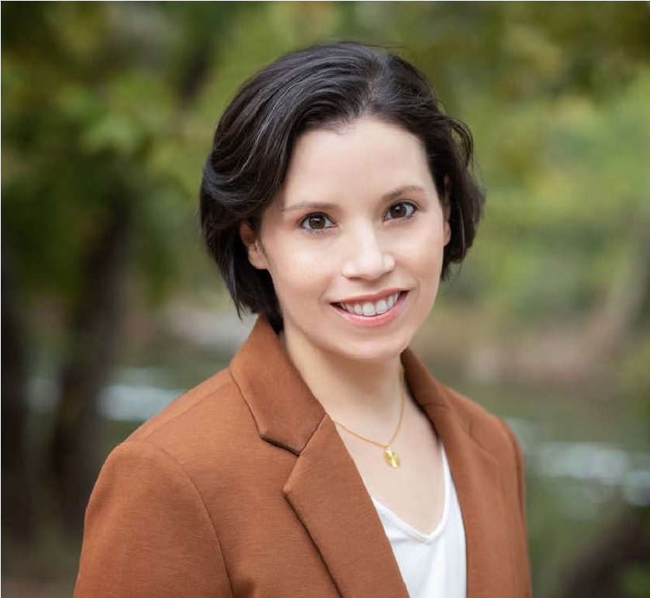
Stefanie T. LoSavio, PhD, ABPP is an Assistant Professor in the Department of Psychiatry and Behavioral Sciences at UT Health San Antonio and a licensed psychologist, board certified in the Behavioral and Cognitive specialty by the American Board of Professional Psychology. Dr. LoSavio works with the STRONG STAR Training Initiative as the Director of Research and Innovation. Dr. LoSavio specializes in evidence-based treatments for posttraumatic stress disorder (PTSD), including cognitive processing therapy (CPT), prolonged exposure (PE), and written exposure therapy (WET). She is a national CPT and WET trainer and regularly provides consultation in these models for research trials and training initiatives. In her research, Dr. LoSavio studies the effectiveness of interventions for PTSD and adaptations to treatments and training methods to increase the reach of evidence-based care.

Brooke Fina, LCSW, BCD
Director of Behavioral Health Training Initiatives

Brooke A. Fina, LCSW, BCD, is an Associate Professor within the Department of Psychiatry and Behavioral Sciences at UT Health San Antonio and a Licensed Clinical Social Worker. She is the Director of Behavioral Health Training Initiatives for the STRONG STAR Training Initiative. She is a clinician, trainer, and facilitates the implementation of PTSD and suicide clinical and non-clinical programs. She provides training and consultation in Prolonged Exposure and Written Exposure Therapy for PTSD, and Crisis Response Planning for suicide prevention. She has consulted with hundreds of mental health providers and community organizations regarding the successful implementation of PTSD treatment programs, consulted with managed care entities, and published outcomes in peer-reviewed journals.

Special Accommodations
If you require special accommodations due to a disability, please contact the STRONG STAR Training Initiative at admin@strongstartraining.org one week prior to the workshop so that we may provide you with appropriate service.

Continuing Education

The STRONG STAR Training Initiative offers attendees 10 Continuing Education (CE) Credits for participating in the 2-day workshop. Participants who attend are eligible to receive 10 CE Credits. To obtain CE Credits, attendees must sign in at the start of the course and sign out after its conclusion. Inquiries regarding CE may be directed via email to admin@strongstartraining.org.

Our continuing education credits have historically been recognized by most professional state licensing boards. However, this is not guaranteed. Please check with your licensing board for verification.

The University of Texas Health Science Center at San Antonio is approved by the American Psychological Association (APA) to sponsor continuing education for psychologists. The University of Texas Health Science Center at San Antonio maintains responsibility for this program and its content.

Cancellation, Substitutions, and Refunds

Registration fees, minus a $50 service charge, will be refunded to participants who send a written cancellation via email to admin@strongstartraining.org postmarked no less than 15 days before the training. No refunds will be made thereafter. A colleague may be substituted for no extra charge if STRONG STAR Training Initiative is notified at least two business days before the training. Alternative, you may choose to reschedule to a future Learning Community with no additional cost.

For additional information, please contact the STRONG STAR Training Initiative at
admin@strongstartraining.org.

AGENDA
Please note Agenda time is based on Central Time Zone

 | Day 1
9:00 am – 9:15 am |  | Welcome and Opening Remarks
9:15 am – 10:00 am |  | Overview of Trauma, PTSD, and Exposure Therapy
10:00 am – 10:30 am |  | Development and Empirical Support for Written Exposure Therapy (WET)
10:30 am – 10:45 am |  | Break
11:00 am – 11:15 pm |  | Empirical Support for WET (cont’d)
11:15 pm – 12:00 pm |  | Treatment Logistics and WET Session 0
12:00 pm – 1:00 pm |  | Lunch
1:00 pm – 2:00 pm |  | WET Session 0 (cont’d)
2:00 pm – 2:30 pm |  | WET Session 1
2:30 pm – 2:45 pm |  | Break
2:45 pm – 3:15 pm |  | WET Session 1 (cont’d)
3:15 pm – 3:30 pm |  | Day 1 Wrap-up and Q&A

 | Day 2
9:00 am – 9:15 am |  | Welcome Back and Reflections
9:15 am – 10:15 am |  | WET Session 2
10:15 am – 10:30 am |  | WET Session 3
10:30 am – 10:45 am |  | Break
10:45 am – 11:15 pm |  | WET Session 3 (cont’d)
11:15 pm – 12:00 pm |  | WET Session 4
12:00 pm – 1:00 pm |  | Lunch
1:00 pm – 1:30 pm |  | WET Session 4 (cont’d)
1:30 pm – 2:10 pm |  | WET Session 5 and Post-Treatment
2:00 pm – 2:30 pm |  | Clinical Considerations and Delivery via Telehealth
2:30 pm – 2:45 pm |  | Break
2:45 pm – 3:15 pm |  | Additional Case Examples
3:15 pm – 3:30 pm |  | Wrap-up and Q&A

